Figure 3

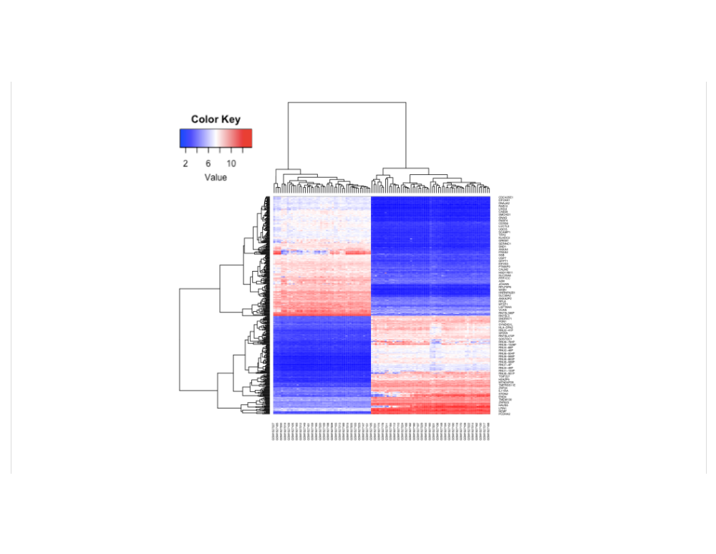

Figure 3. Heatmap demonstrates the top 60 DEGs in PDAC tumor and non-tumor tissues. Each columns present samples and rows present official gene symbols. The gene expression values are converted base-2 logarithmic. The heatmap represents 30 downregulated genes (blue) and 30 upregulated genes (red). The down-to-up-regulated DEGs are represented by the gradual color change from blue to red.

